**Check if any new VM is added**

1. Login to Bluecrest portal.
2. Need to check for Disks and in manage view add column for TimeCreated and export that sheet.

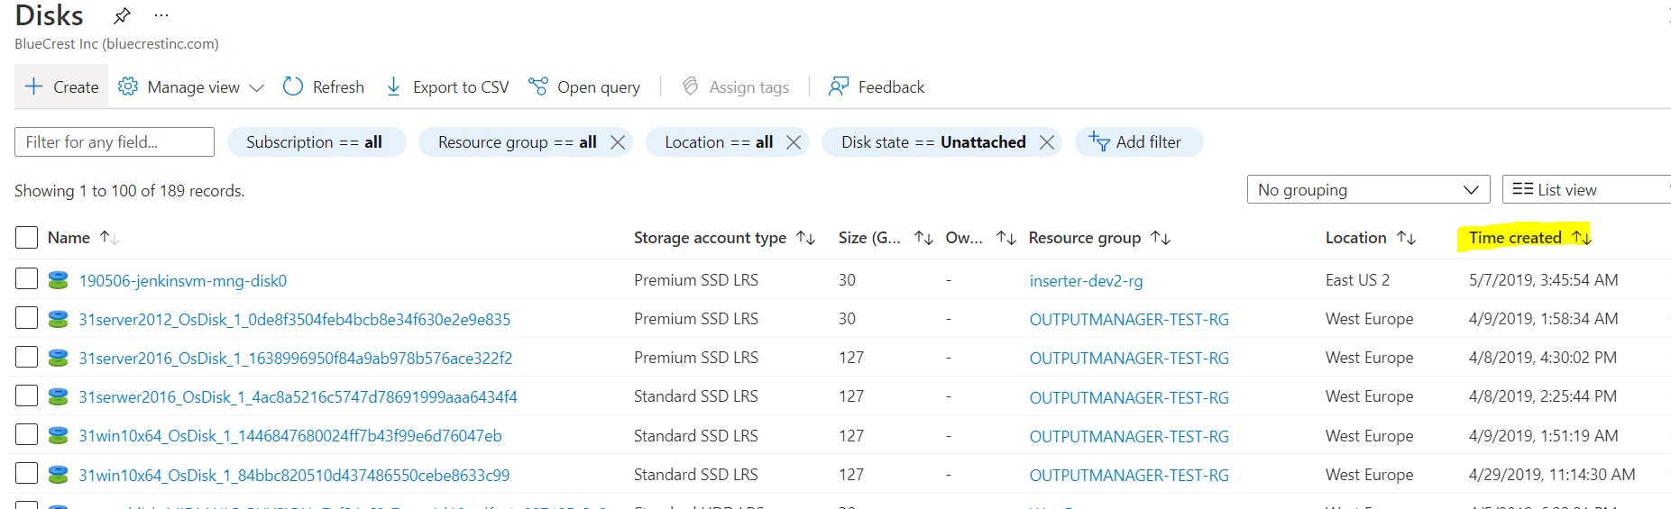

1. Apply filter in exported sheet with current month for Time created column and check whether any new VM’s OS disk is created.

NOTE:- To know when the VM is created we will get to know by checking VM’s OS disk time creation date.

